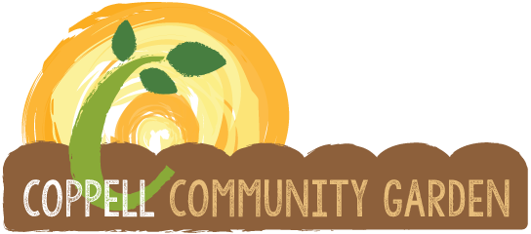

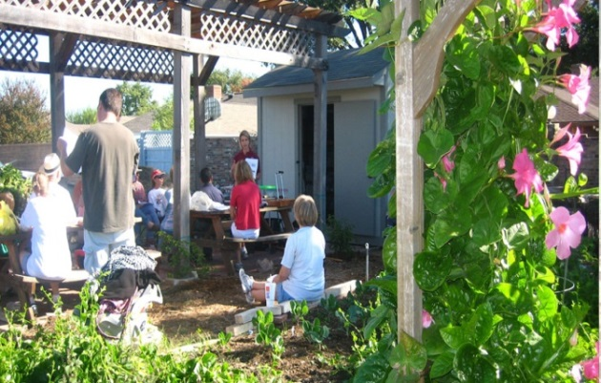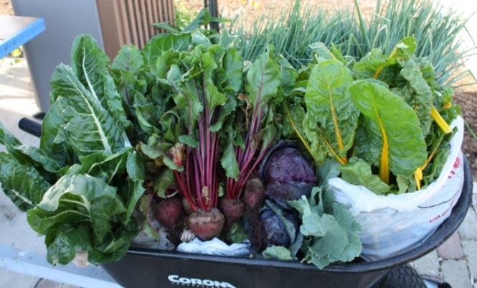



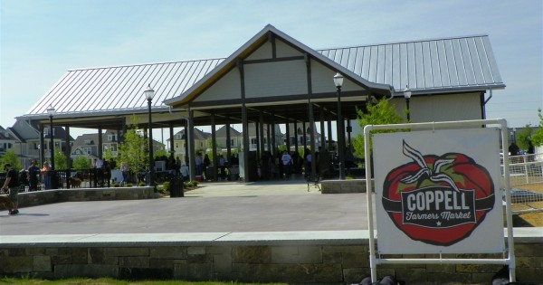

Coppell Sustainable Food Organization
October 1, 2022– September 30, 2023
Annual Report

MISSION
Coppell Sustainable Food Organization (CSFO)
A non-profit organization that provides community gardens, a farmers’ market and education... Dedicated volunteers cultivate a healthy community by growing and donating organic produce to those in need, providing a market for locally grown food, and teaching sustainable practices.
Coppell Community Garden (CCG)

To create a community setting for volunteers to learn and practice organic gardening methods and grow fresh nutritious produce which is donated to those in need.

Coppell Farmers Market (CFM)
To form a relationship with local growers/producers in order to provide fresh, seasonal produce and agricultural products for our community while fostering a sense of place in Old Town Coppell.

FY 2022 Board
NAME | POSITION |  | NAME | POSITION
Tim Thompson | Past President |  | Unfilled | Member at Large
Marie Conrath | President |  | Jodie Deinhammer | CISD Representative
Vince Sidwell | Vice President |  | Ex-Officio Members
Jodie Deinhammer | Secretary/Records |  | Marissa Olivas | City Liaison
Peggy Rosson | Treasurer/Finance |  | Amanda Austin | CFM Director
Amanda Novak | Farmers Market  Chair |  | Casen McMahan | Metrocrest Services
Hilary Hodgson | Community Garden Chair |  | Youth Involvement Volunteers:
Jayashree Arunachalam | Member at Large |  | Nikhil Kini | Coppell High School
Verghese Thomas | Member at Large |  | Diya Hassan | Coppell High School

BOARD
Our advisory board continues to function smoothly. We conduct regularly scheduled meetings and ad hoc meetings as needed, maintain records and have functioning committee directors from our farmers market and from community gardens reporting at each board meeting. With a notable increased growth of shoppers and visitors during the recent years to our Farmers Market, we have added an additional board session specifically for strategic planning.
We continue to expand and nurture our partnerships with Coppell Schools and with our local community organization, Metrocrest, with whom we collaborate to provide families with fresh produce weekly. During the summer, we collaborated with Metrocrest to help plan and build their own new garden. This year the annual Coppell Community Garden Scholarships have been awarded to two graduating seniors from Coppell High School (Melissa Venegas, Amav Khambete). These were presented by the board president at the Senior Awards Assembly in May, 2023.
Our annual “State of the Organization” informational update will be presented to the City Council on Tuesday, October 24th. Presenters include President Marie Conrath-Bates, Market Chair Amanda Novak, Garden Chair Hilary Hodgson and City Liaison Marissa Olivas.
GARDENS
We continue to be a Partner Garden with North Texas Food Bank by donating all of our produce to the Metrocrest Services Food Pantry. We ended our fiscal year with 25,347 pounds donated. This was slightly more than FY 2022 (24,165) despite weather challenges.

We have a total of 109 volunteer gardeners and their families working 144 plots, plus perennial gardens, SmartScape beds, orchards, pottage, and blueberry patches.

Garden | Location | # Plots | # Gardeners | Garden Manager
Helping Hands | 255 Parkway Blvd (next to Town Center) | 42 | 32 | Diane Lowe
Ground Delivery | 450 S. Denton Tap  (next to Post Office) | 59 | 42 | Marie Luu
Old Town Coppell | 345 W. Bethel Road  (next to Senior Center) | 43 | 35 | Gautam Venkatesan
 | Total | 144 | 109

Garden Plot Enclosures
The cedar boards enclosing our plots weaken and rot over time, requiring repair and replacement. We repaired eleven plots at Helping Hands and replaced eight plots at Helping Hands and 3 plots at Ground Delivery.

As our volunteers age many have asked for taller garden beds. The cost of providing a taller bed would double and/or triple with the traditional cedar board design. To cost effectively meet the need for taller beds while reducing the need for maintenance, the garden decided to try a prefabricated modular system of a proprietary 100% non-toxic material made by Vego Gardens. Using a $6,000 grant from Dallas County, nine Vego beds were installed: six 17” tall beds at Ground Delivery and three 32” extra tall beds at Old Town. Two of the beds at Old Town were new. The program is being evaluated to determine future plans.

Greenhouse
The greenhouse distributed approximately 30,000 transplants to the gardens (25,000) and schools (5,000), which is up substantially from the initial distribution of 2,000 in 2019. The spring plant sale was held at the Farmers Market and sold transplants grown by the greenhouse generating $4000 in proceeds. Increased demand from the gardens and supplying transplants to 17 CISD school gardens prevented us from holding a fall plant sale this year.

A Greenhouse Playbook is under development to ensure knowledge transfer is accurate and timely.

Community Connections
Corporate volunteers from Amazon, Salesforce, Celanese, Walmart and AAA continue to provide helpful services at Old Town and Ground Delivery. Scout troops, church groups, students and other community organizations have also volunteered their time on a variety of projects at Old Town and Ground Delivery.

We continue to encourage and receive donations from gardeners’ employers who participate in employee matching programs and employee-directed grants to help their local communities. The gardens tend to be a popular tour location for local citizens, schools and community groups.

Three scouts completed their Eagle Scout projects at Old Town. Helping Hands has been working with Paul Quinn College (an HBCU institution in South Dallas) to establish a composting program and assist with an Adopt a Plot model like ours for students, faculty, and staff. They also worked with a veterans group to plant perennials from our garden in the campus garden.

A 3-year review of the planting guides developed and implemented at Helping Hands in 2019 found production increased dramatically. The review has been posted to the website to assist other community gardens.

FARMERS MARKET
Market Highlights
2023 marks the Coppell Farmers Market (CFM) 20-year anniversary! We’re so appreciative to have had support from the City of Coppell for the past 20 years.
In 2023 we began to lay the framework for significant growth to maintain supply with a continually increasing demand and to ensure the security of the Market’s future. These efforts included the creation of a second, paid leadership position, the exploration of fundraising options, a new marketing strategy, an assessment of risks to sustaining the organization for years to come, and Market leadership is now working in closer collaboration with the City of Coppell Environmental Health Department on vendor permitting, communications, and health code enforcement.
To address low supply issues, the Market increased the vendor count by 15 vendors in 2023 (from 45 vendors in 2022 to 60 vendors in 2023), and we plan to increase by an additional 15 vendors in 2024. Of the 60 vendors in our lineup, an average of 45-50 vendors attended each market day. This is a big jump from our 2003 opening season when we had just six vendors.
To address the risks and growth limitations associated with one paid leadership role, the Market promoted Amanda Austin to the role of Market Director at the end of 2022 and created a new Market Manager role early in 2023. The new Market Manager is Rachel Weaver, a highly skilled and experienced non-profit management and community-building worker. This is our Director’s, Amanda, eighth year to oversee the market operations.
To financially support the new Market Director and Manager positions in 2023, the Market secured surplus funds from our parent organization, the Coppell Sustainable Food Organization, and applied for the USDA’s Farmers Market Promotion Program grant in the amount of $50,000, to be potentially awarded later this fall for the 2024 budget year.
To assist with increased marketing efforts, the Market secured a long-term grant from Google which covers the full cost of Google Workspace, Analytics, and Ads. Google Ads directs about 2.5k people to our market per month when they search in Google for “a farmers market near me”.
In partnership with Coppell Community Experiences, the Market launched a digital education and marketing series called Vendor Tips, where a professional videographer produces 2–3-minute videos that feature our vendors and their expertise. The videos are filmed on market days and show the vibrancy of our Market. The videos have been featured in the City newsletter, the Market newsletter, and the Market’s social media.
A committee of 15 citizen volunteers continues to contribute more than 1000 hours annually in support of the Coppell Farmers Market. The Committee is tasked with advising the Director, ensuring the mission of the Market is sustained, and assisting with event operations such as staffing our Market Information booth, visiting our vendor’s farms and kitchens, and fundraising initiatives.
In 2023 the CFM established Vendor 101, which is a digital, educational resource that helps us ensure the integrity of our vendors and to educate small businesses who may want to sell at farmers markets. The digital learning platform will go live on November 1, 2023. The program features information about best practices for farmers market vendors, permitting and health code information, marketing, and start-up information for those entering the field.
The CFM entered an agreement with Texas Health Resources in October this year to launch a new food-access program at the market beginning November 1st. This USDA-funded program provides SNAP/EBT users with $30 additional dollars per market visit to spend on fruits and vegetables and an awareness campaign that will feature the CFM on billboards and city bus posters throughout the greater Dallas and metro area.
The CFM is a member of the following organizations: Go Texan, The National Farmers Market Coalition, the Farm and Ranch Freedom Alliance, the Texas Organic Farmers and Gardeners Association, Slow Food DFW, and The Texas Center for Local Food. We are certified by the Texas Dept. of Ag as a Texas Farmers Market.

Coppell Community Garden Corporation – dba as Coppell Sustainable Food Organization
FY 23 Actual |  |  |  |  |  |  | FY 2023 BUDGET
INCOME | Gardens | Market | Board | Total |  |  | Gardens | Market | Board | Total
City of Coppell | 8000 | 10000 | 7000 | 25000 |  |  | 8000 | 10000 | 7000 | 25000
Garden- Donation & Grants | 15337 |  |  | 15337 |  |  | 6000 |  |  | 6000
City of Coppell- Market Mgmt |  | 75000 |  | 75000 |  |  |  | 75000 |  | 75000
Garden - Plant Sales | 4592 |  |  | 4592 |  |  | 3000 |  |  | 3000
Garden - Plot Fees | 190 |  |  | 190 |  |  | 200 |  |  | 200
Garden-Donation Greenhouse | 0 |  |  | 0 |  |  |  |  |  | 0
Market - Farm To Table |  | 8608 |  | 8608 |  |  |  | 10800 |  | 10800
Market-Other Income |  | 0 |  | 0 |  |  |  | 5000 |  | 5000
Market - Donations |  | 865 |  | 865 |  |  |  |  |  | 0
Market - Token program - fees |  | 2070 |  | 2070 |  |  |  |  |  | 0
Market - Stall Fees |  | 36550 |  | 36550 |  |  |  | 42000 |  | 42000
Board - Donations |  |  | 191 | 191 |  |  |  |  |  | 0
Surplus Allocation |  | 20000 | 5000 | 25000 |  |  |  | 20000 | 5000 | 25000
TOTAL INCOME | 28119 | 153093 | 12191 | 193403 |  |  | 17200 | 162800 | 12000 | 192000
EXPENSES | Gardens | Market | Board | Total |  |  | Gardens | Market | Board | Total
Garden - Mowing | 1470 |  |  | 1470 |  |  | 1200 |  |  | 1200
Garden - Seeds | 893 |  |  | 893 |  |  | 1300 |  |  | 1300
Garden - Structures / Shed | 3037 |  |  | 3037 |  |  | 200 |  |  | 200
Garden - Supplies | 9071 |  |  | 9071 |  |  | 3500 |  |  | 3500
Garden-Mulch-Compost | 0 |  |  | 0 |  |  | 1300 |  |  | 1300
Garden- Soil Amendment-pest | 673 |  |  | 673 |  |  | 3000 |  |  | 3000
Garden -Google fees | 1633 |  |  | 1633 |  |  | 200 |  |  | 200
Garden - Misc replace boards | 11238 |  |  | 11238 |  |  | 2000 |  |  | 2000
Garden -website | 1650 |  |  | 1650 |  |  | 1800 |  |  | 1800
Garden - Greenhouse | 1612 |  |  | 1612 |  |  | 3200 |  |  | 3200
Market-Advertising & Promotions |  | 100 |  | 100 |  |  |  |  |  | 0
Market - Director |  | 87092 |  | 87092 |  |  |  | 87000 |  | 87000
Market - Assistants |  | 5340 |  | 5340 |  |  |  | 5700 |  | 5700
Market - Manager |  | 24115 |  | 24115 |  |  |  | 31500 |  | 31500
Market - EFunds Charges |  | 3671 |  | 3671 |  |  |  | 2600 |  | 2600
Market - Farm To Table |  | 1838 |  | 1838 |  |  |  | 4000 |  | 4000
Market - Chef Demo- Training |  | 200 |  | 200 |  |  |  |  |  | 0
Market - SNAP Administrator (Sandy) |  | 5600 |  | 5600 |  |  |  | 5500 |  | 5500
Market-workers comp ins |  | 1046 |  | 1046 |  |  |  | 1500 |  | 1500
Market- Operating |  | 15509 |  | 15509 |  |  |  | 25000 |  | 25000
Market - Website |  | 0 |  | 0 |  |  |  |  |  | 0
Board - Community Donations |  |  | 0 | 0 |  |  |  |  |  | 0
Board - Events/ Harvest Dinner |  |  | 1861 | 1861 |  |  |  |  | 2250 | 2250
Board - Bank Charges |  |  | 0 | 0 |  |  |  |  |  | 0
Board - Postage |  |  | 0 | 0 |  |  |  |  | 150 | 150
Board - Insurance |  |  | 1264 | 1264 |  |  |  |  | 2600 | 2600
Board - Scholarship |  |  | 2500 | 2500 |  |  |  |  | 2000 | 2000
Board - School Garden- CISD |  |  | 0 | 0 |  |  |  |  | 0 | 0
Board - Misc |  |  | 6213 | 6213 |  |  |  |  | 5000 | 5000
TOTAL EXPENSES | 31277 | 144511 | 11838 | 187626 |  |  | 17700 | 162800 | 12000 | 192500
Net Income | -3158 | 8582 | 353 | 5778 |  |  | -500 | 0 | 0 | -500

Submitted by:
Marie Conrath-Bates, President
November, 2023

